**User-Defined Electronics**

“Built by Us, Designed by You”

Team:

Prabhu Avula - AP18110010409

Sumanth Kongani - AP18110010413

Harshitha Bokkisam - AP18110010437

**Acknowledgment**

We would like to thank each of our team members for their support throughout the course of this project. We must also thank our professor, Ms. Meghana, and our mentor, Mr. Sanjeev Kumar, and the staff at Green Pearl Education, for their support, mentorship, advice and guidance, without which this project would not have been possible.

Aim

The aim of this project is to provide a smooth selection experience for the user when he chooses to purchase a mobile phone. His decision will be influenced by information and data about the specifications of each mobile phone such as processor, power, display size, OS, camera, and more.

Project Synopsis

**Purpose:**

To create a centralized digital interface for the purchase of mobile phones based on the desired specifications of the user. The user is prompted to provide the specifications he is looking for in a mobile phone, and based on the inputs received, the results showcasing mobiles tailoring to his search specifications will appear out of which he may select one. The advantage here is the user does not need to compromise on any specifications. In other words, he has no constraints when searching for a product. The web application is designed using HTML, CSS, JS, PHP to design a smooth and attractive front end experience and the backend will be done using MySQL.

**Existing System:**

Although there are some glimpses of an application showcasing these qualities, they often compromise the specifications asked by the user, and hence the quality of output does not always seem favorable to the user. With this in mind, it is safe to say that a system such as the one discussed before does not exist.

**Proposed System:**

Phones and other digitally handheld devices can be categorized as such:

Smartphone.

Flip phone.

Tablets.

Foldable Phone.

Each of these phones is distinct from the other. They are governed by the following specifications:

Processor: Qualcomm Snapdragon, Kirin, Exynos, MediaTek, etc.

Display size: 4” - 7”.

Display Type: O-LED, LCD, LED, TFT, etc.

Operating System: Android, Ubuntu Touch, LineageOS.

Front Camera: 8MP - 32MP.

Rear Camera: 8MP - 108MP.

Number of Cameras: 1-4.

Speaker Type (Acoustics): Stereo, Mono, Front-Firing, Top-Firing, In-Display.

Security: Passcode, Face Recognition, Thumbprint, IR.

RAM: 2GB - 12GB.

Storage: 32GB - 512GB.

Battery Capacity: 2000mAh - 10000mAh.

Charger Type: Wired (10W - 120W), Wireless (15W).

Color: #000000 - #FFFFFF

Designs: Gradient, Lines, Vinyl, Matte, Metallic, Glass, Gloss, Ceramic, Decals, etc.

Body: Aluminium, Plastic, Stainless Steel, etc.

The user may select his preferences and build a customized smartphone.

**Details Handled:**

It is a web application that has been carefully designed to ensure a highly efficient and smooth experience for the user. Once the user opens the webpage, he is prompted to click on a button that says “Customize”. Upon clicking that button, he will be asked to select the processor he needs. After this, he will be guided through the series of main specifications that are compatible with the selected processor. Out of the given options, the user can choose the specifications he likes in each category to finish up his customization experience. Upon finishing, the user may click the “Order” button. This adds his order request to the cart. This entire experience will be built using HTML, CSS, JS, PHP and other web developing language tools.

**Assumptions:**

1. Users that do not use proprietary software can use this application freely.
2. There is no other competition in the current market.

**Sample Scenario:**

Harshad Mehta is a very wealthy person who has a desire to have a perfect phone. Out of all the phones he has used, he has been dissatisfied in one or more aspects. So, to resolve this issue, he simply goes to the User Defined Electronics (UDE) online store and chooses the specifications he wants so that he can extract the maximum efficiency and satisfaction when using this mobile for his busy stockbroker job.

**Who Can Use This Application in Real Life:**

People, like Harshad Mehta (in the aforementioned sample scenario), who are very busy in their work-life, and who are constantly in need of a good, strong, and durable phone to conduct business are the prime target audience for this product. A person who wants to institute all his wants into one finished product can use the UDE store to custom build the phone he wants.

**Technology Used:**

SQL, CSS, Bootstrap, HTML, Js, Servlet, PHP, WAMP Server, phpMyAdmin.

**Introduction**

With the ever-advancing fields of science leading to new, cutting-edge, ground-breaking and innovative technology, people have become more accustomed to technological benefits such as speed and efficiency. One of those technologies is the mobile phone.

Whether it’s a call from your boss asking for some work reports, or a call to family abroad, mobile phones have forever changed how we perceive technology now. Smartphones are a handheld computer. They are quick, efficient, long-lasting, and are capable of performing all the essential tasks needed for a user, and much more. However, the problem arises when the need of the people just edges forward than the capabilities of a simple smartphone.

For example, a businessman requires a well-built, long-lasting phone to make several calls a day to ensure that his business keeps moving. Although most phones have all the features and specifications he would need, none of them incorporate ALL his requirements. The businessman is often forced to compromise on some specification in order to get the best phone, yet. User-Defined Electronics (UDE) addresses that simple, yet frustrating issue with a very innovative solution sprung from an age-old, simple concept: Customization.

Our idea of customization and our innovative approach to it truly changes the perspective with which we perceive technology by opening an avenue of new outcomes and possibilities. With the customization approach, a person can now have everything he desires incorporated into a single machine. A person can completely bypass the routine phase of compromising upon a specification and get what he truly desires.

UDE also has future plans to expand this innovative approach of customization to other fields in technologies such as laptops, desktops, computers, smartwatches, and so much more. We really want to give you what you truly desire. Built by Us, Designed by You.

**Body Report**

**Front End:**

The front end of our website consists of a very aesthetic, beautiful, and easy to navigate webpage with easy access links and information regarding UDE and our vision. It is on the webpage that a customer can place his order for the electronic device of his desires.

Upon entering the webpage, the user can scroll through to find information about our company, our grand vision, the architects of that vision, a few important statistics that define our work, and a few testimonials from customers who want to share their experience. The user can navigate through and understand what UDE is and what it stands for.

The webpage is designed in such a way that navigating through is a walk in the park. In order to actually place an order, the customer is required to have an account registered with a valid email ID. Upon successful registration, the customer can now log in and can place an order.

When a customer wants to place an order, he is redirected to a webpage where each and every specification is asked, and upon giving his desired specifications and clicking the confirm order button, his order will be placed. It is that simple.

**Back End:**

Our backend is very clean and simple, we do not like clutter. Our innovative way of organizing information ensures its safe location and security. Our databases have all the information regarding each of our customers, our supply stock for each component we use while building an electronic device.

During registration, the user gives his email and a password. This critical data is encrypted to ensure its safety and is stored in one of several tables in our vast database. Easy to access and keep account of, it ensures that all the information is safe and secure. After the registration is finished, the user can attempt to log in. Once he enters his credentials on the login page and clicks the “login” button, the credentials he has entered are cross-checked with the credentials in our database and if they match, the login attempt is successful.

After logging in successfully, the customer may place his order by choosing from the endless options of specifications that lead to several combinations that can be installed into the final product. After choosing his desirable specifications and clicking the “place order” button, each and every bit of information pertaining to the order is carefully and securely transported to their respective tables in our database.

At UDE, we give a lot of importance to every detail pertaining to our customers and hence we employ the highest methods of data encryption to make sure our data is safe and secure. Our partners at Code Break ensure this. So, the doubt of security is completely squashed. Simply log in, and design the phone of your desires.

**Work Flow:**

The UI workflow of User-Defined Electronics is as follows

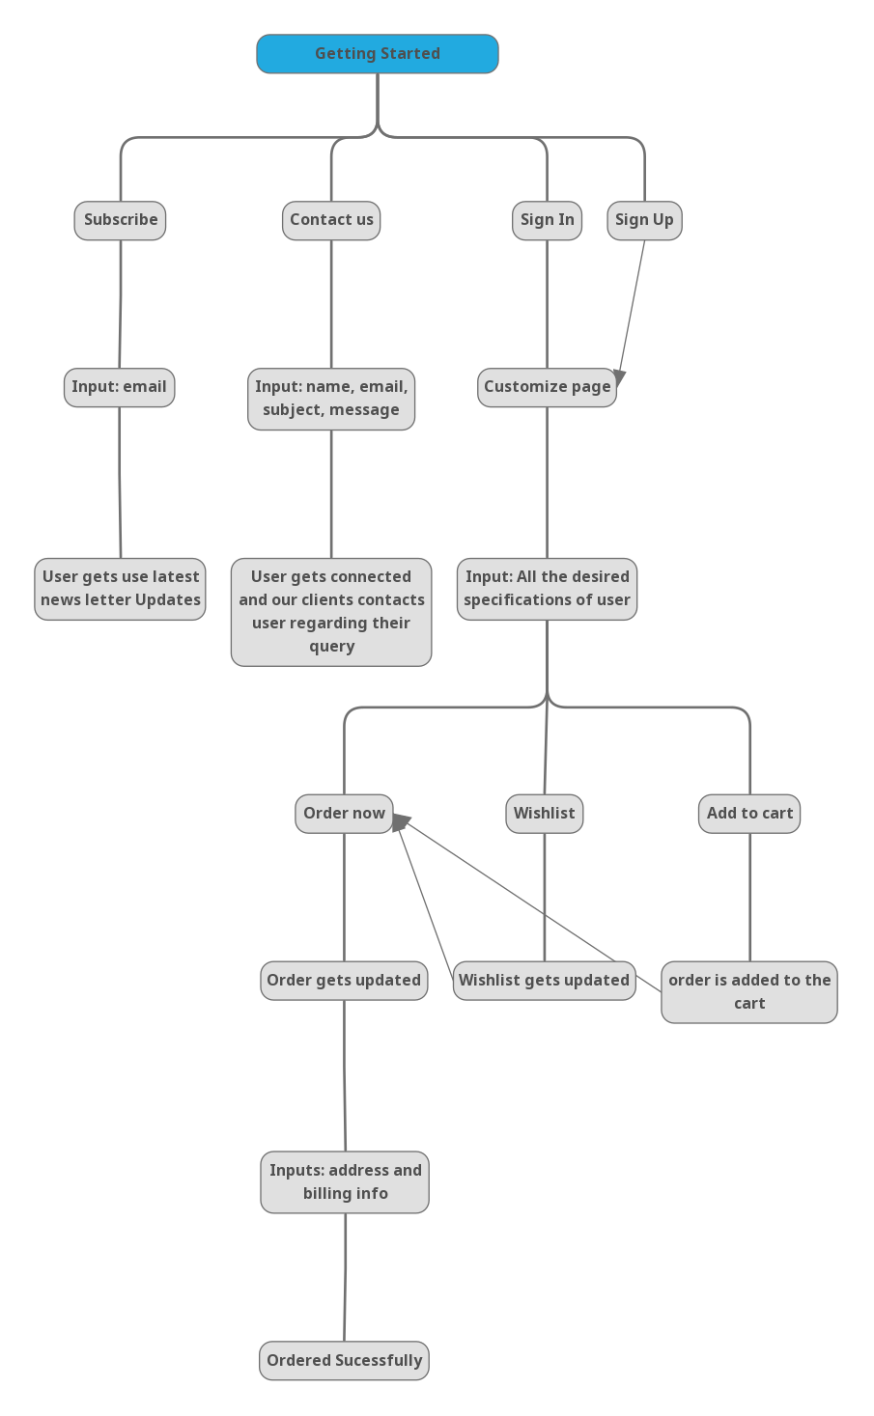

Here are some of the UI workflow images of User-Defined Electronics

Home page: The first glimpse of the UDE website

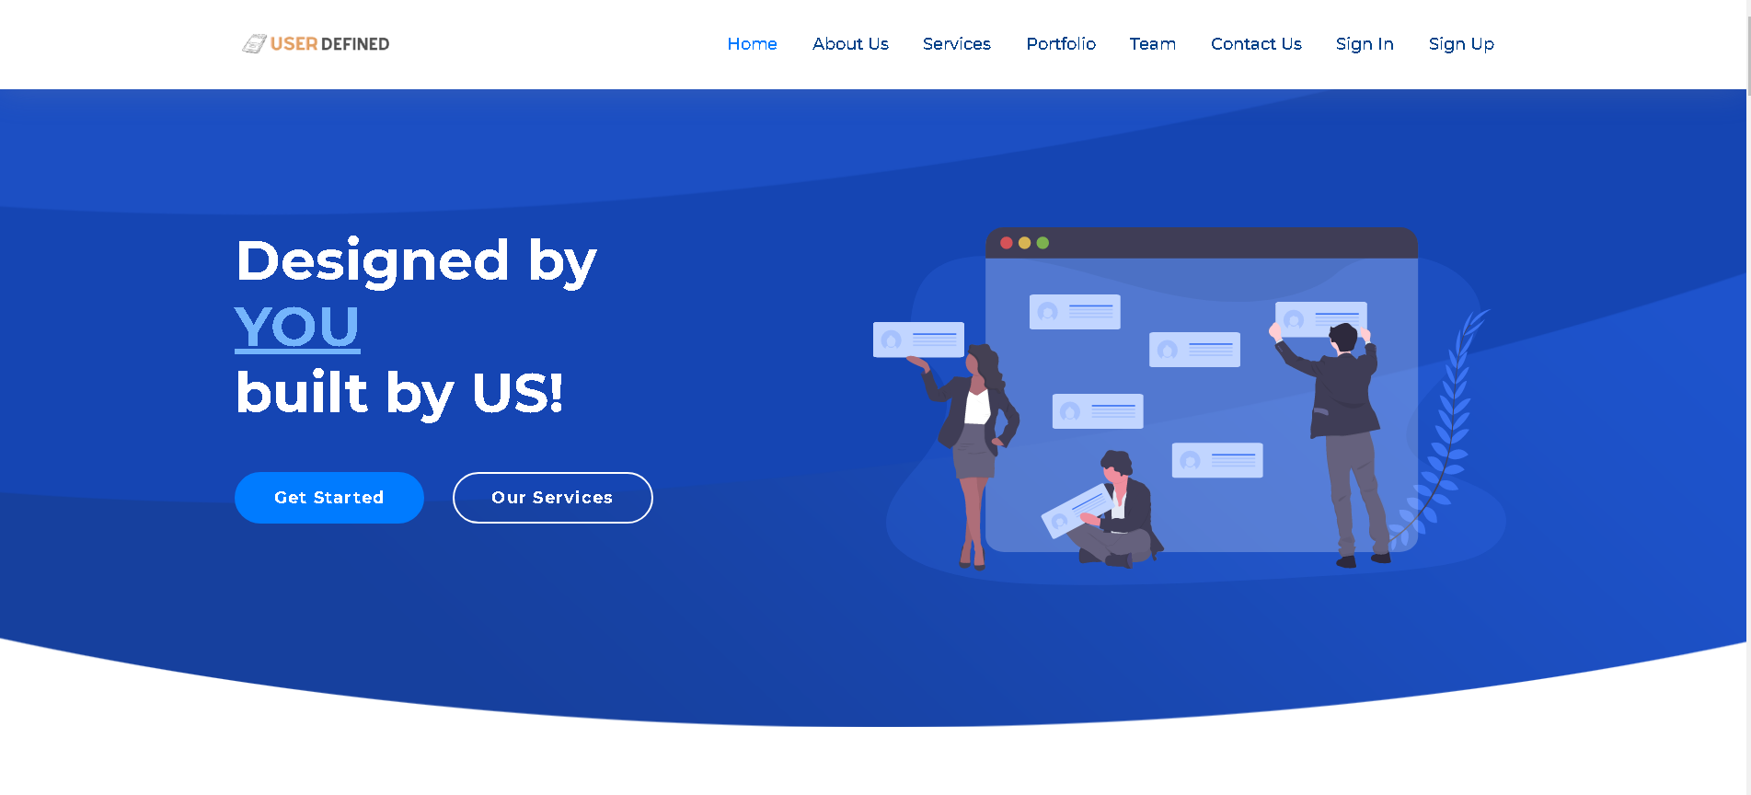

Here user either Sign In or press gt started to log in to his account and start customizing his/her mobile phone with his/her desired specifications

Sign In and Sign Up page: The user starts a new session by signing into the UDE account and get started.

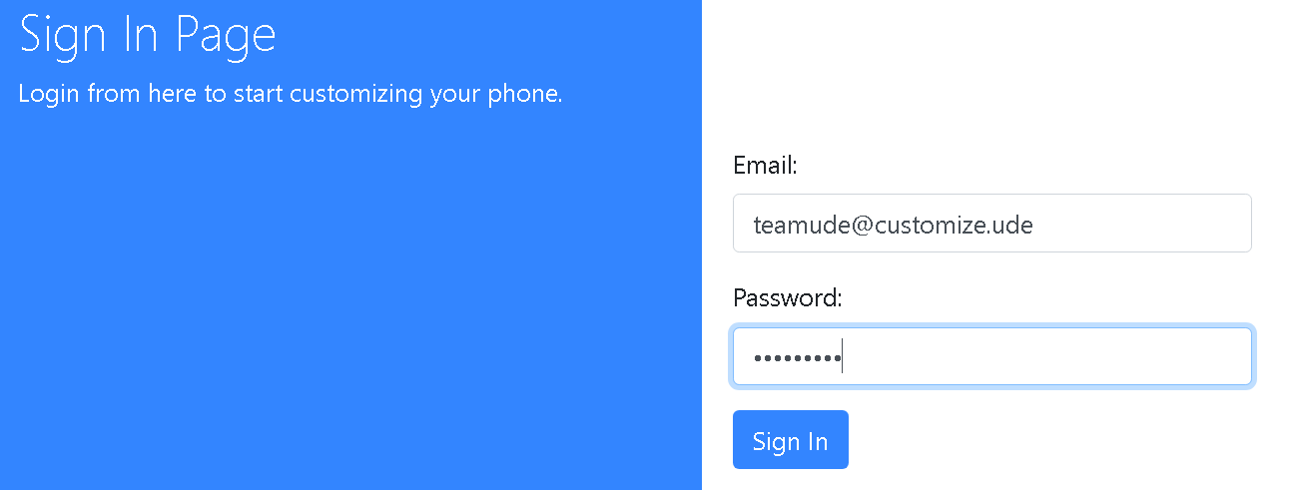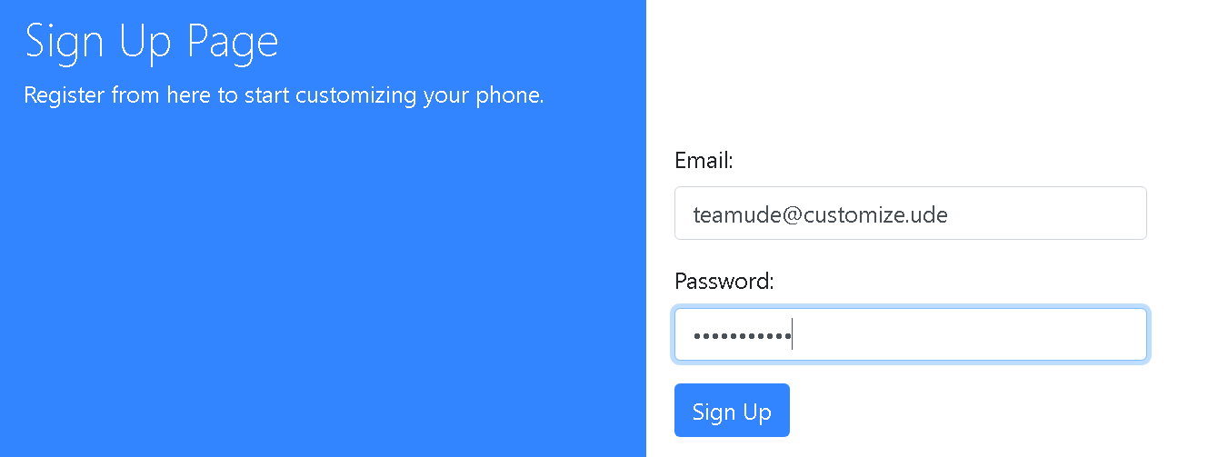

The backend authentication is stored in the MySQL server and the user data is as follows:

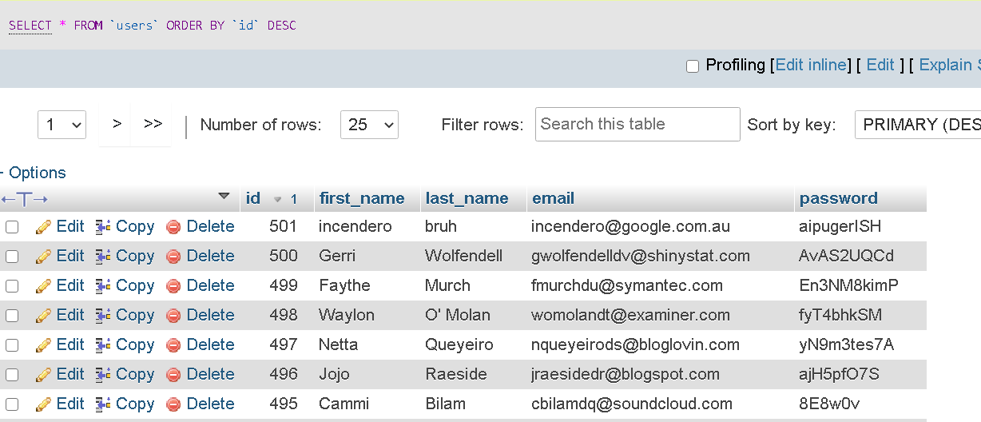

After Signing in to the UDE account user can start customizing his/her mobile phone with our responsive UI.

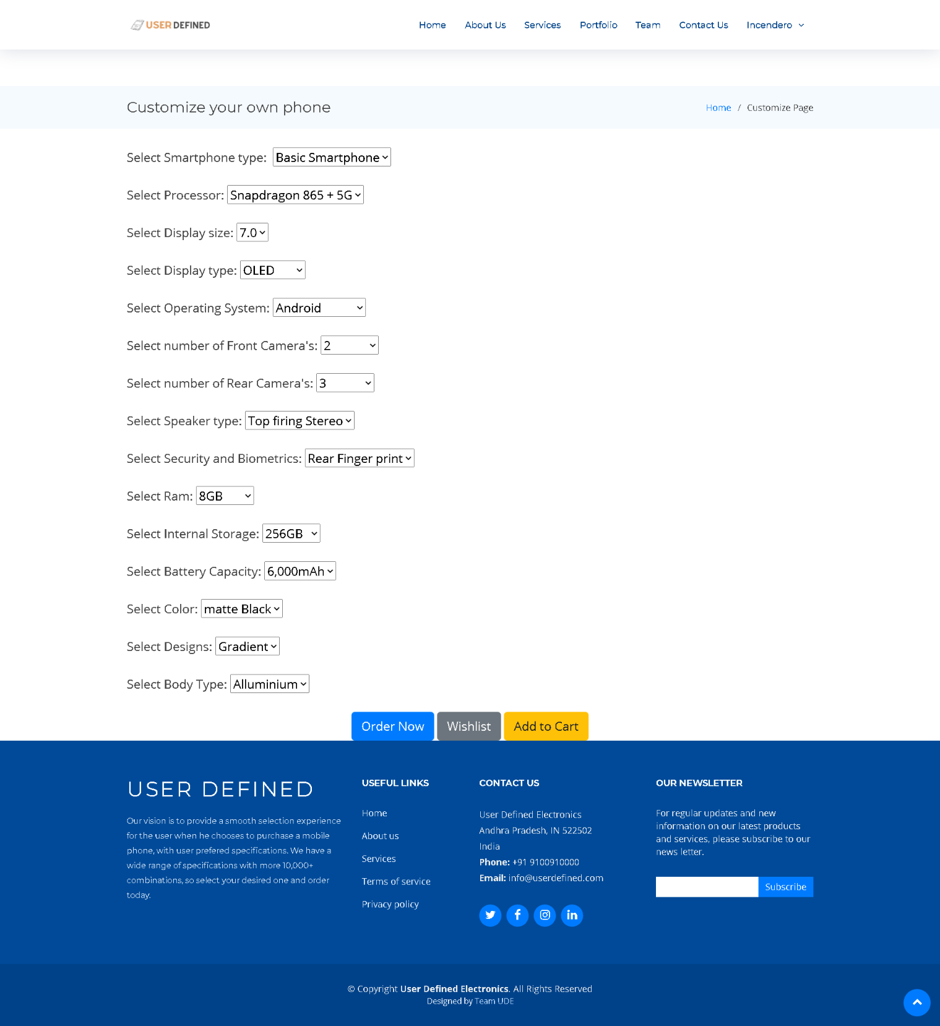

Once the user clicks on the wishlist the selected specifications will be added to his wishlist and he can start customizing his other desired specifications if the user needs time to order his mobile he can add the product to the cart and order it later. If the user wants to buy it he can press order now and after few addresses and billing confirmations, orders will be confirmed and will be ready for production.

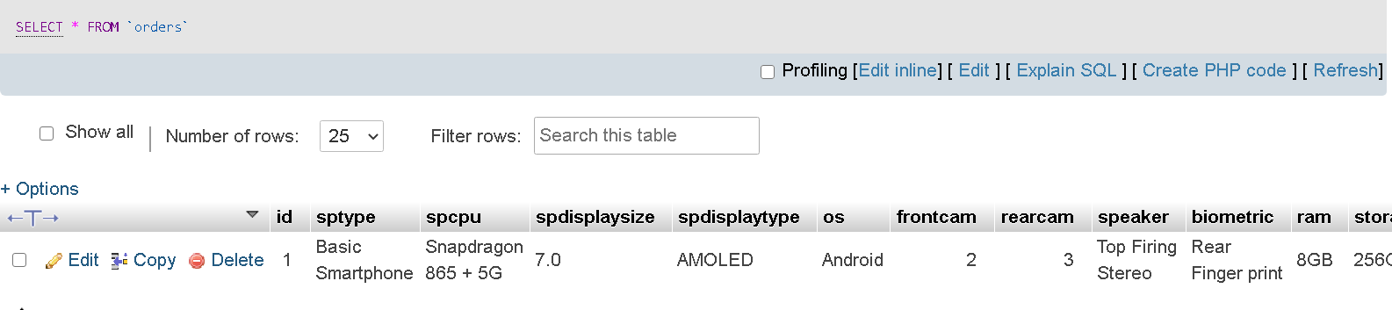

The users can write to us in the contact us page

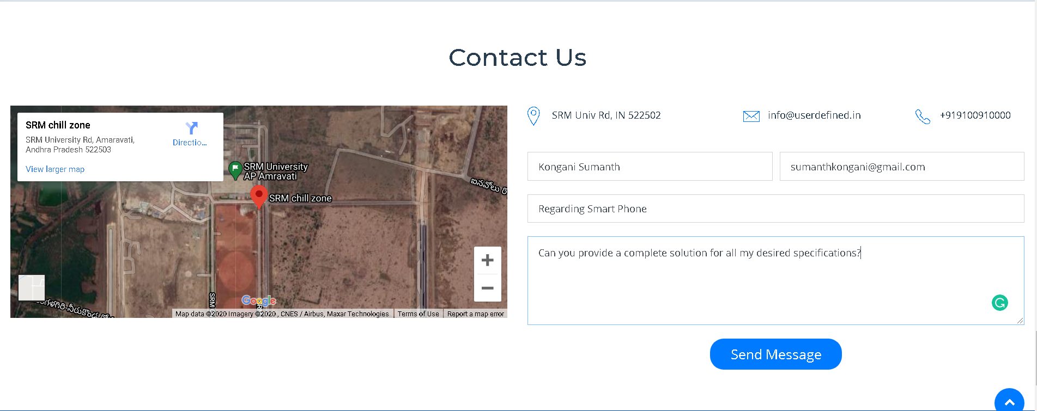

The inputs of Contact Us will be stored in our SQL database and we reply back to them using the email provided by the user in the email input field.

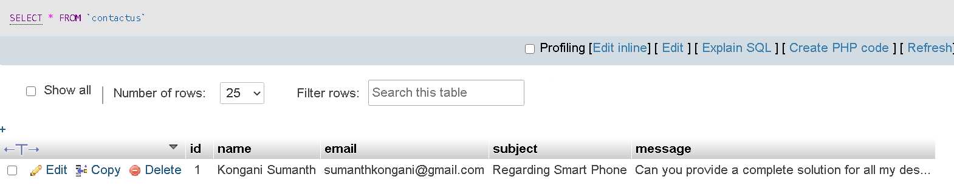

The user can even subscribe to our newsletter for regular updates and new information on our latest products and services. The user is just required to enter an email.

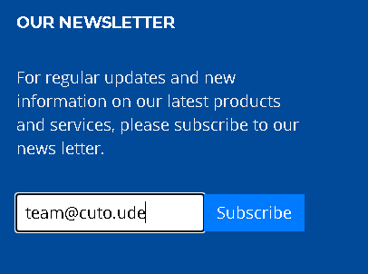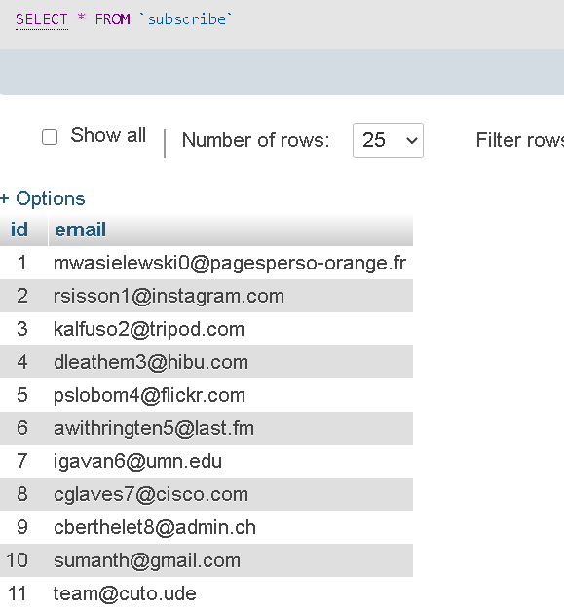

**Future Plan:**

UDE has a lot of plans for the foreseeable future. We will expand our innovative approach to other technological fields such as laptops, desktops, smartwatches, tablets, and many more. Furthermore, we intend to find better ways to do what we do now in our pursuit of technological perfection.

**Conclusion**

User-Defined Electronics has provided a smooth selection experience for the user when he chooses to purchase a mobile phone with a very innovative approach. His decision will be influenced by information and data about the specifications of each mobile phone such as processor, power, display size, OS, camera, and more.